Scenario 1: Extend C Drive Space by 10GB and Create AMI Snapshot (Rollback Ready)
Now we could see that we have only have 5.75GB free space. Lets extend the space by 10GB.
- Let’s take an AMI snapshot before the activity so that we can restore as a rollback.
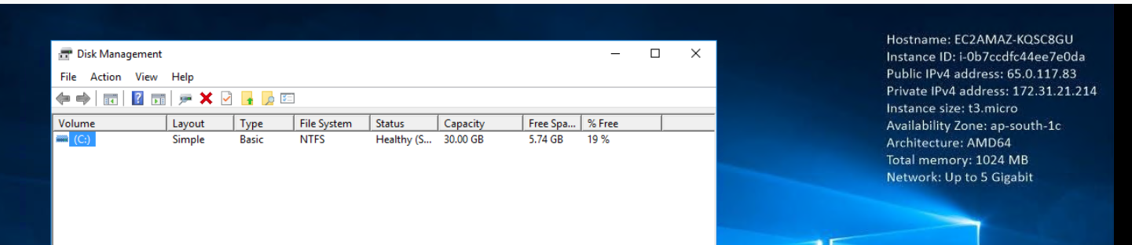
Step 1: lets take an AMI snapshot before the activity.
Select the instance > click on Actions > select Image and Templates
And click on create Image.
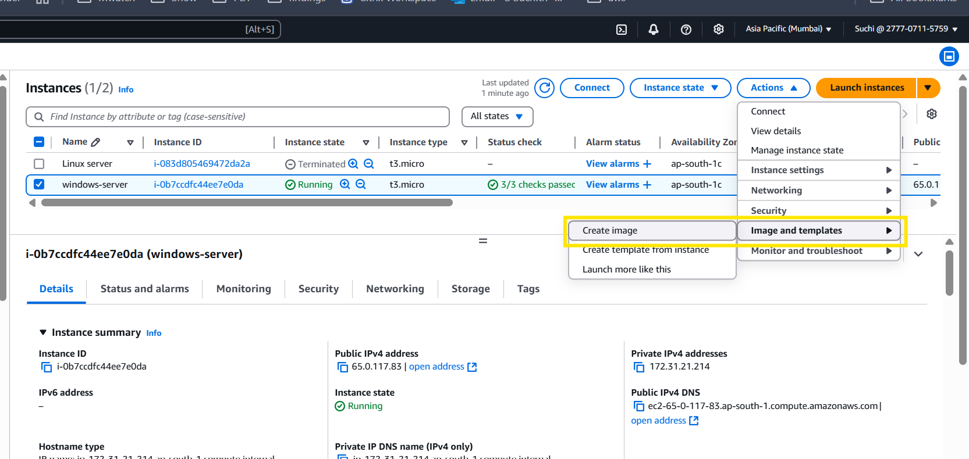
Step 2: specify the inputs as per the snips.
Note:
Reboot Option: Not mandatory; skip reboot if uptime is critical.
Volume Size: Do Not change; AMI automatically captures existing size.
EBS Encryption: If source volume is encrypted, snapshot will be too.
Post-Launch: Encrypt AMI by copying snapshot to encrypted one.

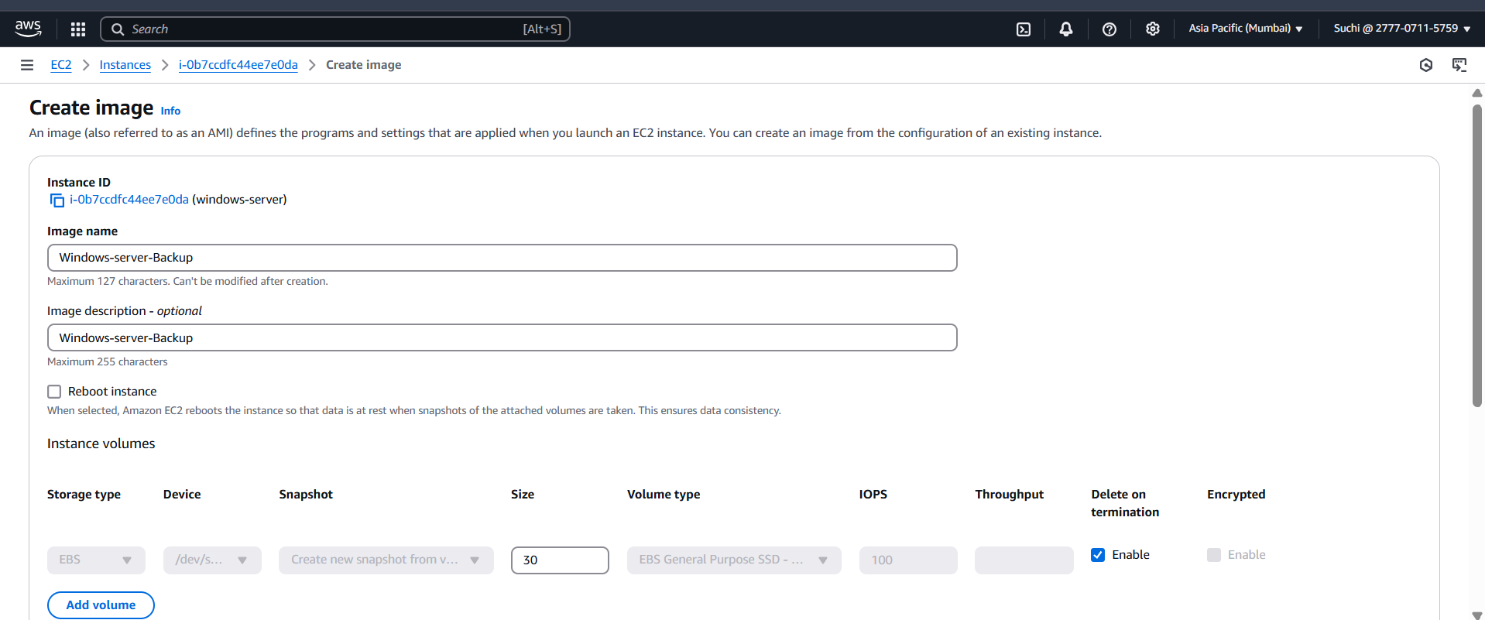
And click on create image.
Step 3: it takes time to create a snapshot let’s wait for it. Post that we can see that snapshot is created.
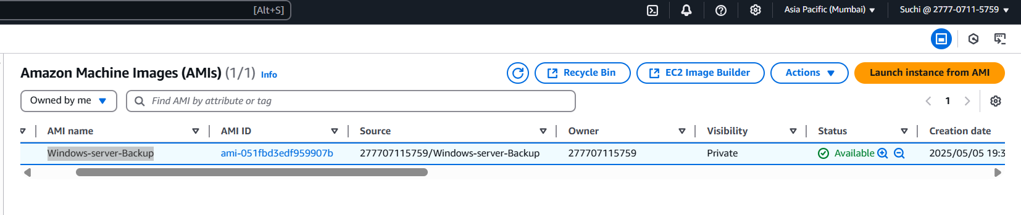
Step 4: Create extend an EBS volume by 10GB now.
Step 5: click on windows-server instance > scroll to storage and click on the volume ID.
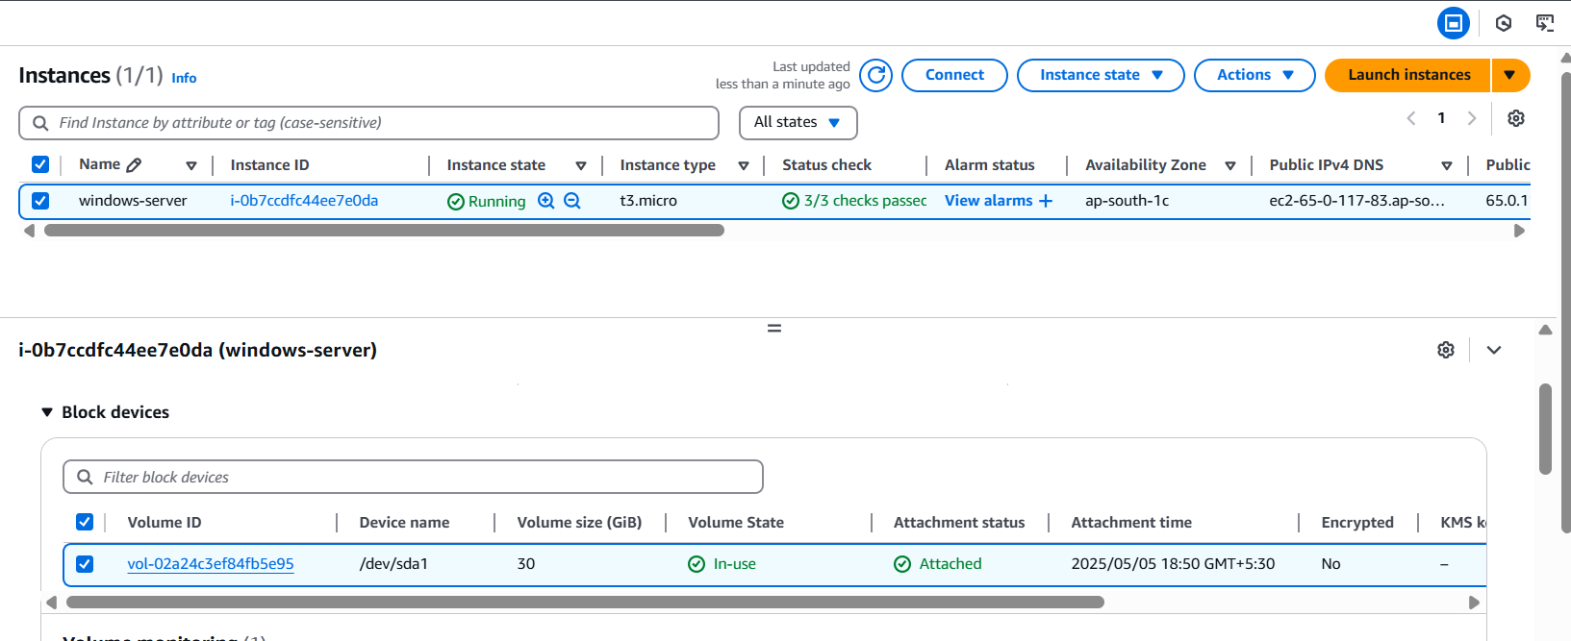
Step 6: select the volume > actions > modify volume.
Ensure it’s the right instance volume.
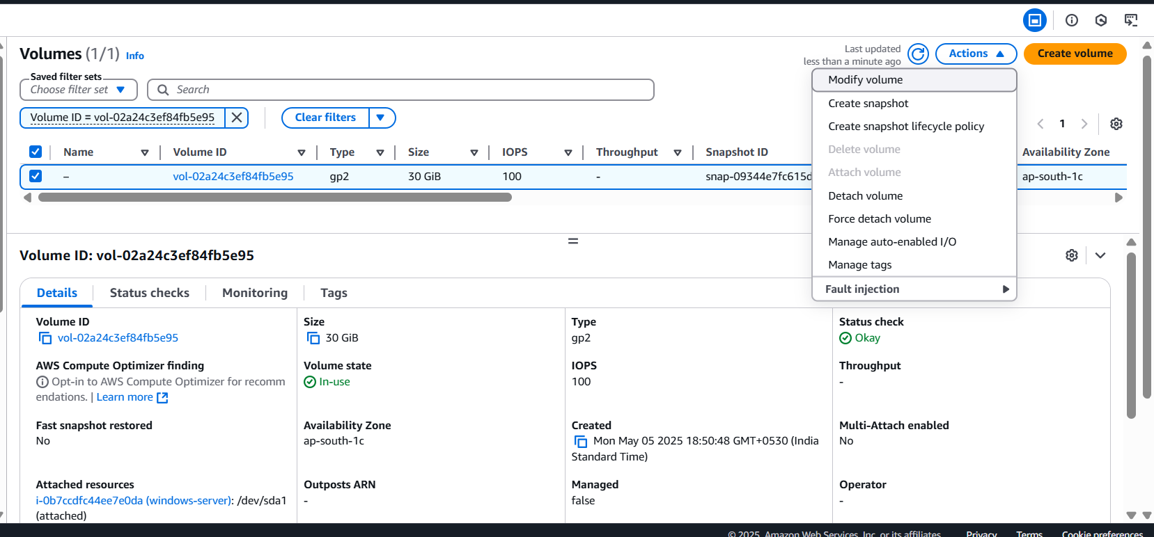
Step 7: we need to increase it by 10GB right.
Now currently is 30 , so edit it and set as 40GB.
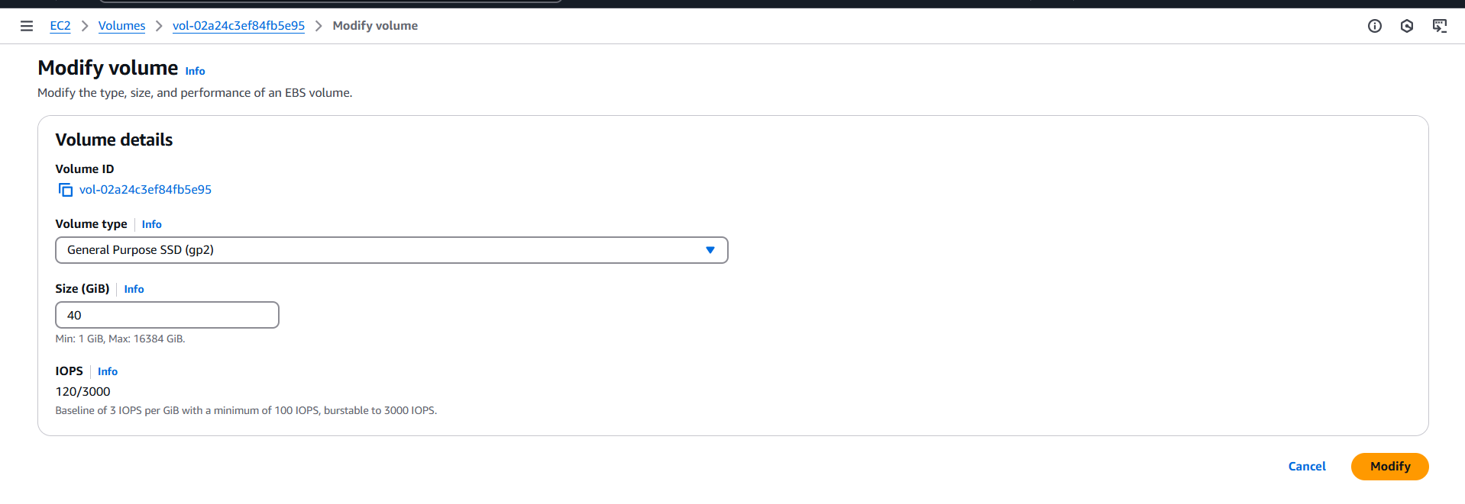
Step 8: and click on modify.
Step 9: login to server and validate.
And extend it from OS level.
We could see that 10GB of unallocated space as been created.
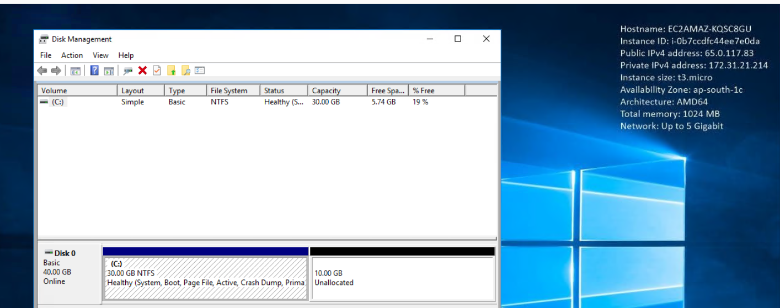
Step 10: right click on C drive and select > extend volume
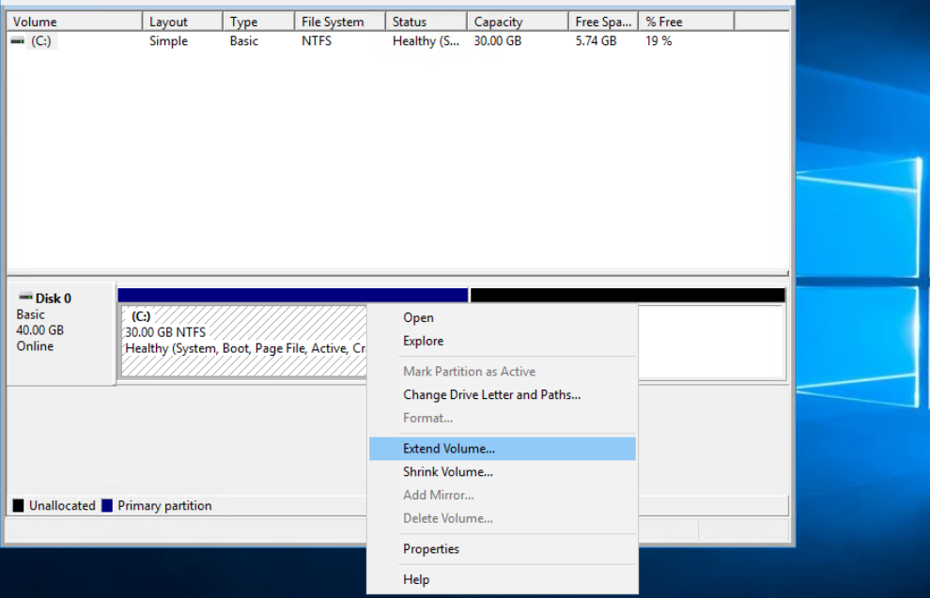
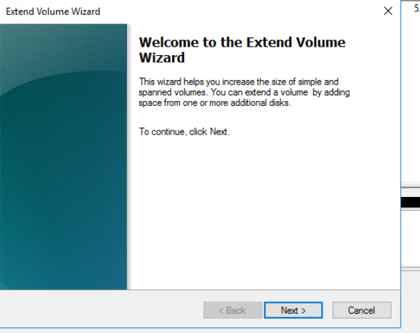
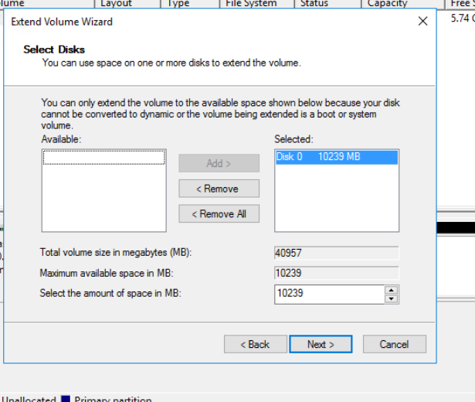
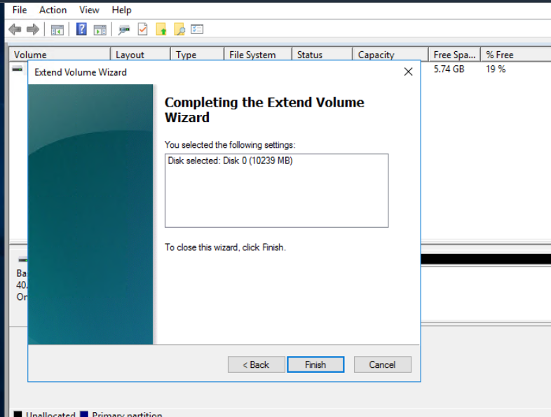
Step 11: now we could that C drive is expanded by 10GB
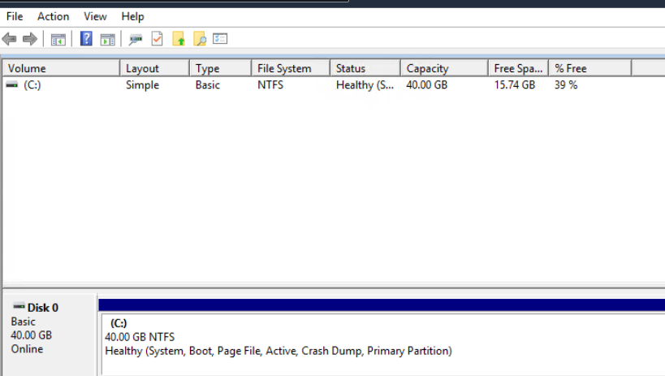

NOW if you want to rollback.
Step 1: EC2 console > scroll down to AMI
Select the backed-up image and select launch instance from AMI
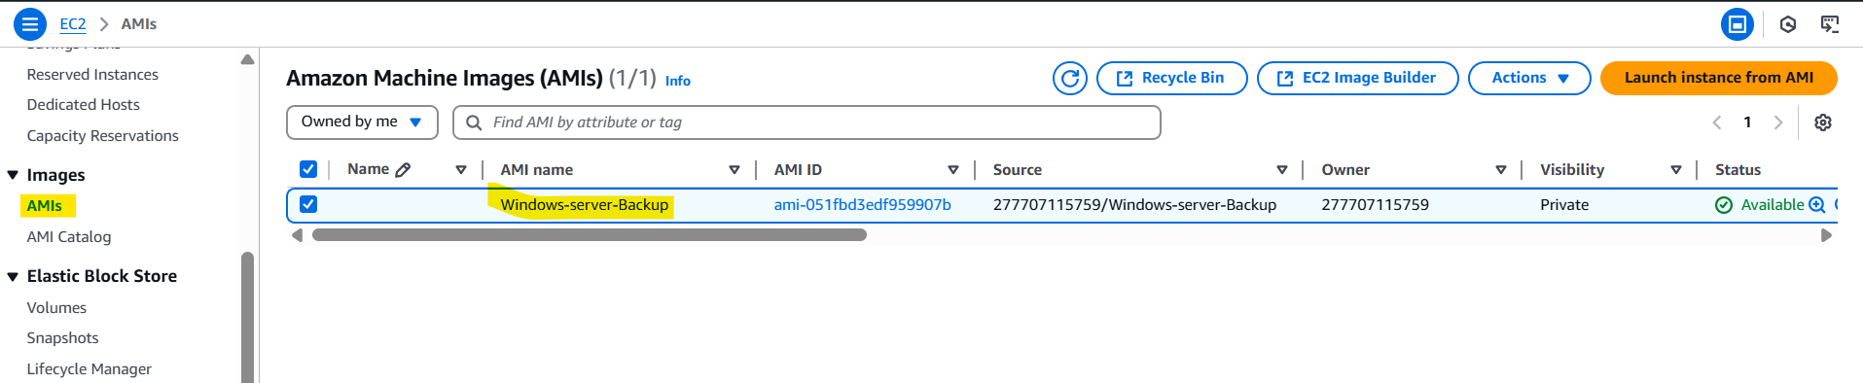
Step 2: provide the name and we could see the image is taken from Backed-up AMI.
Specify the VPC, key pair, security groups. And then click on launch instance.
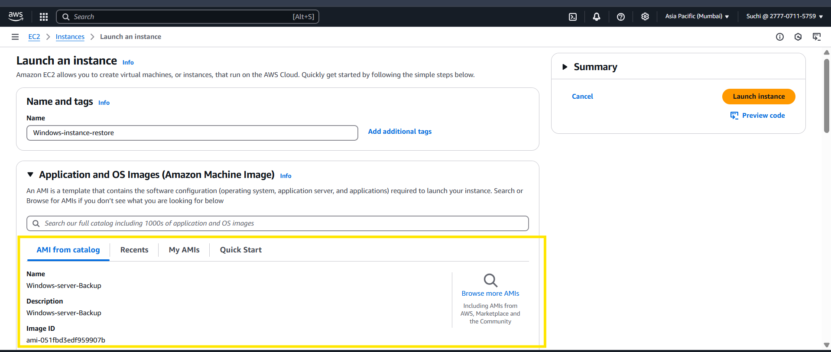
Step : we can turn off the older instance and then we can change the server’s name back to windows-server.
If need we can add back the server to domain and change the hostname to earlier.

